AMPS (Advanced Message Processing System) is a high-performance, low-latency messaging platform designed for financial, IoT, and other real-time systems. It supports dynamic messaging formats like JSON, XML, and binary and provides features such as message filtering, aggregation, and stateful subscriptions.

Key Concepts
- WrapperMessage
  - A WrapperMessage encapsulates the actual payload or business message being transmitted over AMPS.
  - Contains metadata, routing information, or other system-level data necessary for message processing.
  - Helps decouple application data from transport-related metadata.
  - Structure Example:
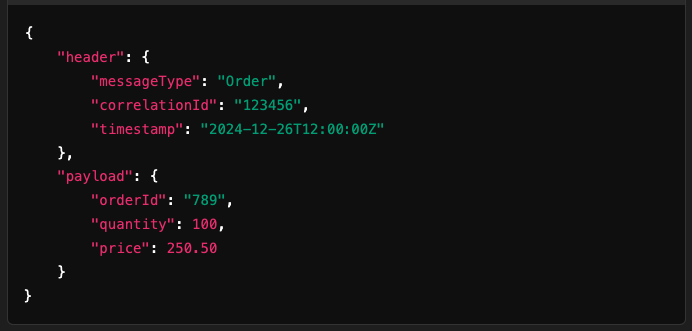
  - Header: Metadata like timestamps, message type, or correlation IDs.
  - Payload: The actual data (e.g., order information).

- JSON in AMPS
  - JSON is a popular format in AMPS due to its flexibility and human readability.
  - AMPS provides JSON filtering and query capabilities using XPath-like syntax.
  - Supports advanced operations, such as:
    - Content-based filtering: Subscriptions with criteria based on JSON fields.
    - Projection: Selecting specific JSON fields in responses.
  - Example Subscription Query:
- Use Case:
  - A client subscribes to trade messages where tradeAmount > 1000.

- AMPS Authentication
AMPS provides several authentication mechanisms to ensure secure access to messaging services:
Types of Authentication
  - Basic Authentication:
    - Uses username/password credentials.
    - Configured in the AMPS server or external authentication systems.
  - Token-Based Authentication:
    - Clients provide an authentication token for access.
    - Useful for integrating with external Identity Providers (IdPs) like OAuth.
  - Certificate-Based Authentication:
    - Mutual TLS (mTLS) for client-server authentication.
    - Requires a public key infrastructure (PKI) for managing certificates.
  - Custom Authentication:
    - Developers can implement custom authentication logic using AMPS server plugins or external APIs.
  - Configuration Example:
In the AMPS configuration file:
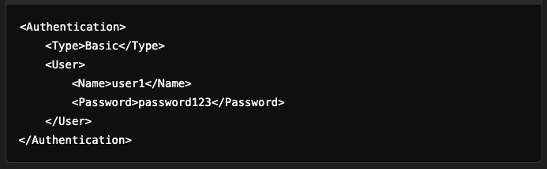

Workflow: WrapperMessage, JSON, and Authentication
- Client Authentication:
  - A client connects to the AMPS server and provides credentials (e.g., username/password or token).
  - The AMPS server validates the credentials against its internal store or an external system.
- Message Publishing:
  - The client sends a WrapperMessage to a topic.
  - Example:
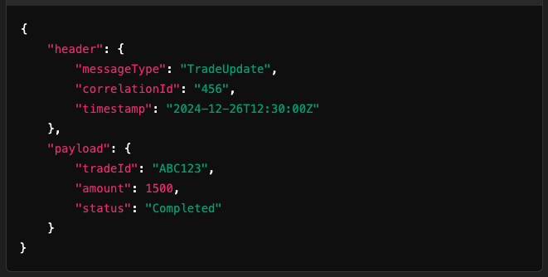
- Message Filtering:
  - Consumers subscribe to topics using JSON field-based filters.
  - Example:

- Message Delivery:
  - AMPS delivers only the messages matching the filter to the subscriber.
  - Metadata from the WrapperMessage can assist in routing or correlation.
- Encryption and Security:
  - Communication between clients and the AMPS server is secured using SSL/TLS.
  - Authentication ensures that only authorized clients can publish/subscribe.

Key Features and Benefits
- WrapperMessage:
  - Decouples transport details from business data.
  - Facilitates extensibility by allowing custom metadata.
- JSON Support:
  - Enables flexible, real-time filtering and querying.
  - Simplifies integration with modern systems using REST or microservices.
- Authentication:
  - Ensures secure access to AMPS topics.
  - Supports enterprise-grade security practices like mTLS and token-based authentication.

AMPS Use Cases
- Financial Trading Systems:
  - Real-time trade updates with filtering based on price, volume, or status.
- IoT Applications:
  - Streaming telemetry data with JSON queries for selective processing.
- Event-Driven Architectures:
  - Wrapping events in WrapperMessage for routing and correlation.

